1. Get started with Azure AI Services
   1. Prepare to develop AI solutions on Azure

* Definition of AI： A software can do a series of human-like actions.
  + 1. Visual perception
    2. Text analysis
    3. Speech
    4. Decision making
* AI related terms：

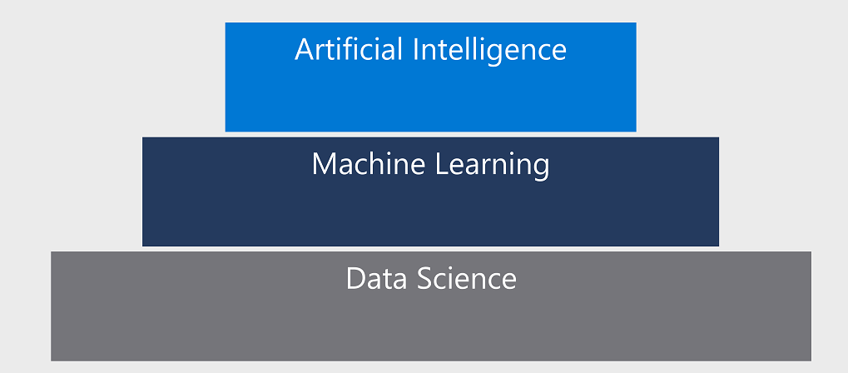

* Azure is a cloud-based platform for running experiments to train model from data, and publish the model as a service.

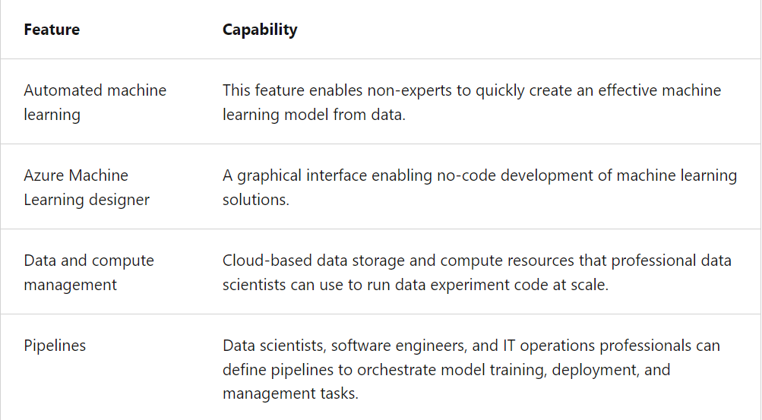

* Main category for Azure AI：

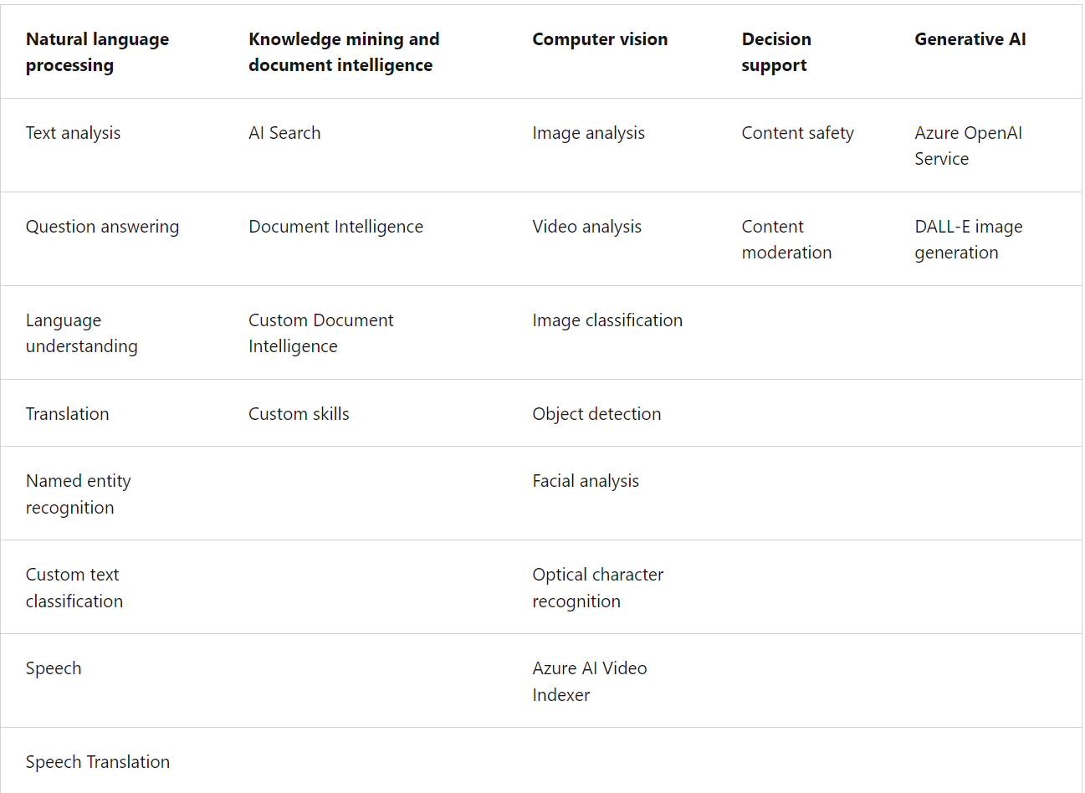

* 1. Create and consume Azure AI services
* Azure AI services：

**Azure AI Document Intelligence** - An optical character recognition (OCR) solution that can extract semantic meaning from forms, such as invoices, receipts, and others.

**Azure AI Immersive Reader** - A reading solution that supports people of all ages and abilities.

**Azure Cognitive Search** - A cloud-scale search solution that uses AI services to extract insights from data and documents.

**Azure OpenAI** - An Azure Cognitive Service that provides access to the capabilities of OpenAI GPT-4.

* Endpoints and keys：

**The endpoint URI**. This is the HTTP address at which the REST interface for the service can be accessed. Most AI services software development kits (SDKs) use the endpoint URI to initiate a connection to the endpoint.

**A subscription key**. Access to the endpoint is restricted based on a subscription key. Client applications must provide a valid key to consume the service.

**The resource location**. When you provision a resource in Azure, you generally assign it to a location, which determines the Azure data center in which the resource is defined. While most SDKs use the endpoint URI to connect to the service, some require the location.

* Request：

1. REST api through http request.
2. SDK.
   1. Secure Azure AI services

* Authentications for Azure AI services：
  + - 1. Regenerate the keys with command line：az cognitiveservices account keys regenerate
      2. Regenerate keys with Azure portal：

1. In the Azure portal, go to your resource's Keys and Endpoint pane.
2. Then select Regenerate Key1 or select Regenerate Key2, depending on which one you want to regenerate at the time.
   * + 1. Use Azure key vault to protect the key.

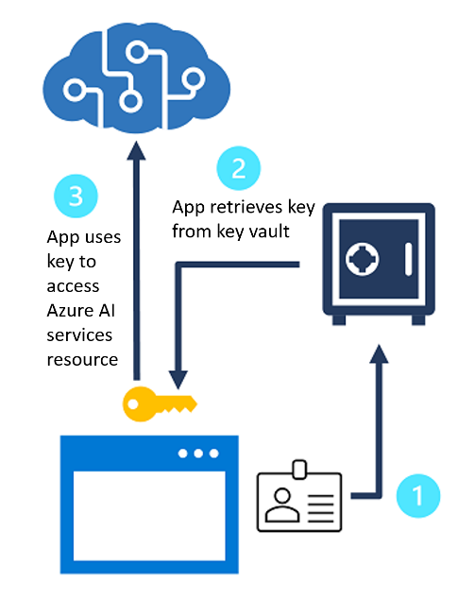

* + - 1. Create a custom subdomain and assign a role to a service principle.
      2. Managed identities：

System-assigned identity：Link to azure resource.

User-assigned identity：Use multiple resource.

* 1. Monitor Azure AI services
  2. Deploy Azure AI services in containers

1. Create computer vision solutions with Azure AI Vision
2. Develop natural language processing solutions with Azure AI Services
3. Implement knowledge mining with Azure AI Search
4. Develop solutions with Azure AI Document Intelligence
5. Develop Generative AI solutions with Azure OpenAI Service